**Unit Code: ITEC200**

**Assignment #: Fire NSW Database**

**Student Name: Ashwanth Sai P. S**

**Student Number: S00274996**

**Lecturer Name: Mr Utpal Nanavati**

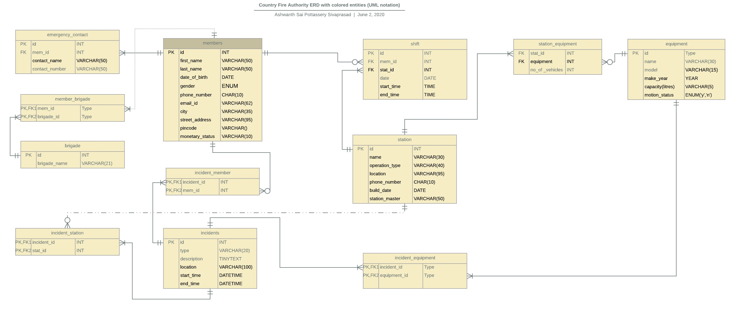

Assumptions

1. Multiple stations, members can be involved in an incident
2. At least one equipment, one station, one member is involved in an incident
3. A member can only have a single monetary status.
4. At least One member is always scheduled at a station
5. Multiple members can be allocated at a station at a time eg high risk periods
6. Members can be allocated Different Stations in Roster.
7. Members May or may not be allocated in a roster.
8. Multiple members can be allocated the same shift. Member 1 and 4 could be allocated for shift 3, between 1200 - 1300 hours
9. There is at least one member allocated at a station at a time.

Design Constraints

1. Gender is not given NULL constraint; this is to include people who wish to keep their gender unspecified.
2. Phone number is given 10 characters to include area code within the number.
3. Emergency contact is given a different table, this is because nature of firefighting operations is dangerous. It is advised to keep multiple emergency contacts. However, some people might not be able to provide multiple contacts. Emergency contact table will take cater both cases.
4. Tankers with 2x2 and 4x4 configurations are included as same entity with different model names in the equipment _table.

2x2A2011 corresponds to 2x2 configuration, 4X4A2022 corresponds to 4x4 configuration.  
Aerial appliances with and without pump are given different model names. P2005 corresponds to model with integrated pump, NP1996 corresponds to model without integrated pump.

1. Members are given a default shift period of 3 hours. For extensive work times, multiple shifts are allocated. Half and quarter shifts are not permitted within the roster.

QUERIES

1. Which stations were built after 1999?

SELECT id,name, location FROM stations

WHERE YEAR (build_date) >1999;

1. Which stations have trucks that are made earlier than 1990?

SELECT e.name,q.no_of_vehicle,e.make_year,s.name,s.location FROM station_equipment q

JOIN stations s ON q.stat_id = s.id

JOIN equipment e ON q.equipment_id = e.id

WHERE make_year<1990;

1. How much is the total water capacity of all tankers(in litres)?

SELECT SUM(capacity) FROM equipment;

1. What is the frequency of using each type of trucks in the incidents (sorted from high to low)?

SELECT e.name, COUNT(ie.incident_id) FROM incident_equipment ie

JOIN equipment e ON e.id = ie.equipment_id

GROUP BY e.name

HAVING COUNT(ie.incident_id) >1

ORDER BY COUNT(ie.incident_id) DESC;

1. Which stations have been involved in more than one incident?

SELECT s.name,COUNT(incident_id) FROM incident_station q

JOIN stations s ON s.id=q.stat_id

GROUP BY s.name

HAVING COUNT(incident_id)>1;

1. What is the total number of hours each volunteer member worked for CFA?

The default shift is 3 hours. Total number of hours is equal to no of shifts x 3.

SELECT CONCAT(m.first_name,m.last_name) AS name, COUNT(s.id)*3 AS hours FROM shifts s

JOIN member m ON m.id=s.mem_id

GROUP BY name;

1. List the members involved in an incident (of your choice)

Incident no 1 is chosen.

SELECT m.first_name, m.last_name FROM incident_member im

JOIN member m ON im.mem_id=m.id

WHERE incident_id = 1;

1. List the stations that haveat least a HazMat Van and at least 2 tankers
2. Create a query that merges the result of Query1 and Query5 and shows the result in a single list?

SELECT s.name,s.location,COUNT(incident_id) AS no_involvement FROM incident_station q

JOIN stations s ON s.id=q.stat_id

WHERE YEAR(s.build_date) >1999

GROUP BY s.name,s.location

HAVING COUNT(incident_id)>1;

1. Create a query that replaces empty (null) phone numbers of members with “###”

UPDATE member

SET phone_number ='###'

WHERE

phone_number IS NULL;